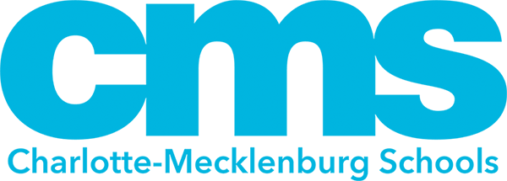

7905 Pleasant Grove Rd.

Charlotte, NC 28216

980-343-6948

December 17, 2024

Dear Parent/Guardian:

As a parent/guardian of a student in **Mountain Island Lake Academy**, I am writingthis letter to let you know that **Mountain Island Lake Academy** has been designated as a Targeted Support & Improvement Additional Targeted Support (TSI-AT) school by the North Carolina State Board of Education. As stated in ESSA Section 1111(d)(2), North Carolina had to identify schools for targeted support and improvement. TSI-AT schools in North Carolina are those that have a subgroup that is under-performing. The intent of this opportunity is to improve educational outcomes for all students, close achievement gaps, increase equity, and improve the quality of instruction.

As a TSI-AT school, **Mountain Island Lake Academy** is required to develop a comprehensive plan that specifically addresses how the school will improve student achievement. The plan will also include how our district will support us and monitor the progress of our school. The comprehensive plan will address the following areas:

* Classroom Management
* Standards-aligned Instruction
* Professional Learning Communities (PLCs)
* Instructional Leadership
* Recruitment & Retention of Effective Teachers
* Support for Grade-to-Grade Transitions
* Implementation of a Tiered Instructional System
* Data-Driven Decision Making
* Student Support Services
* Family and Community Engagement

We have set the following goals for **Mountain Island Lake Academy** this year:

* ***Early Literacy:*** Increase from 35% to 70% as measured by Dibels
* ***3-8 Reading:*** Increase CCR from 16.1 to 51.1 as measured by EOG
* ***3-8 Math:*** Increase CCR from 16.1 to 51.1 as measured by EOG
* **7th and 8th grade Honors Math:** Increase CCR by 50% as measured by EOG
* ***5th and 8th Science:*** Increase GLP from 45.1 to 70.1 as measured by EOG
* ***Subgroups:*** Increase GLP SWD from 8.9 to 28.9; ML from 23.3 to 43.3; Black from 15.1 to 50.1 as measured by EOG
* ***Attendance:*** Decrease chronic absenteeism from 31.1% to 11.1%.
* ***Discipline:*** Decrease out of school suspensions from 222 to 55.

Our students need to experience higher achievement levels, but it will require hard work on the part of staff, students and families. Here are some strategies **Mountain Island Lake Academy** will be implementing:

* **We** will continue **to** provide opportunities for all scholars to have access to at or **above** grade **level** content that reflects college-and**-**career **ready** academic standards**.** Focus will **be** on acceleration and not remediation to ensure students are accessing grade level content.
* Scholars will be engaged in differentiated learning opportunities and activities that meet their needs.
* Strategic, targeted small-group instruction across all **K-8** classrooms in reading and math based on assessment **data**.

Parent engagement is at the heart of our school improvement efforts. Here are some ways we can work together:

* Make sure that both you and your student are aware of academic expectations set for your student this school year. A list of learning objectives in student-friendly language is available from your student’s teacher(s).
* Call ***Mountain Island Lake Academy at 980-343-6948*** if you have questions or concerns about your student or to set up an appointment to meet with a school staff member who will be working with your student.
* Make sure that your student is prepared and attends school each day.
* Monitor your student’s homework.
* Monitor the progress your student is making and attend meetings with your student’s teacher(s).
* Keep track of our website and social media sites at <https://www.cmsk12.org/mountainislandlakeacademyES>
* Volunteer.
* Join the ***Mountain Island PTSA and/or School Improvement Team***

Sounds like a lot but preparing our students so that they can succeed is not easy and is a group effort. Here are some resources available to help:

* ***Mountain Island Lake Academy 980-342-6948***
* Graduation requirements: [www.ncpublicschools.org/gradrequirements/](http://www.ncpublicschools.org/gradrequirements/)
* K-12 standards in academic subjects: [www.ncpublicschools.org/curriculum/](http://www.ncpublicschools.org/curriculum/)
* State student achievement test results: [www.ncpublicschools.org/accountability/](http://www.ncpublicschools.org/accountability/)
* N.C.School Report Cards: <https://www.dpi.nc.gov/data-reports/school-report-cards>

We’re excited about this school year and are working to make it a success for your student. Already, we have:

* Title 1 Parent Meetings
* Curriculum Night
* Open House
* School Improvement Meetings
* Hispanic Appreciation Month Family Engagement Event

If you have questions about the content of this letter, please contact ***Donna Parker-Tate* at** [**donnaj.parker-tate@cms.k12.nc.us**](mailto:donnaj.parker-tate@cms.k12.nc.us) **or 980-343-6948**.

Sincerely,

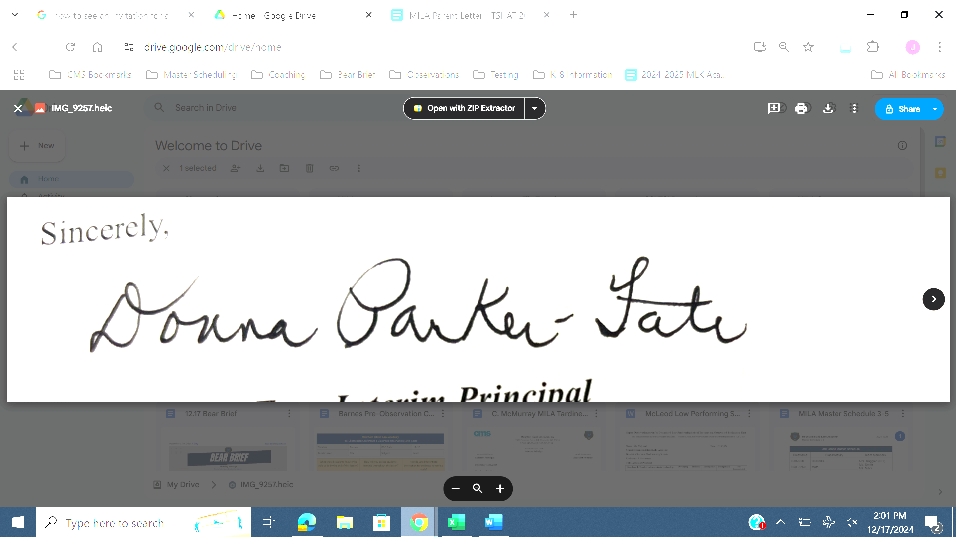

***Donna Parker-Tate, Interim Principal***